a fantabulous time for auditions
'neath the cover of Wien courtyard skies:
our new members

We had a bumper crop of auditionees last semester and welcomed ten (!) wonderful new members into the group! Each of them has provided two true fun facts and one lie about themself…

stupendous sops

Celeste Paerels  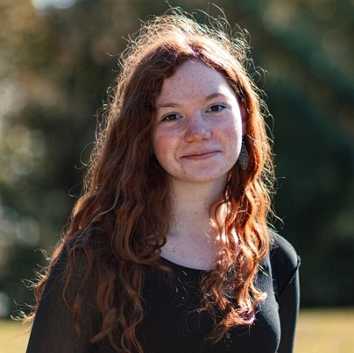  - My chorus and I sang with Julie Andrews on TV  - In kindergarten, people would call me Lester (another popular one was Red)  - I once met Dora the Explora—Boots, too. Unfortunately, Swiper couldn't make it. | Lizzy Carpenter  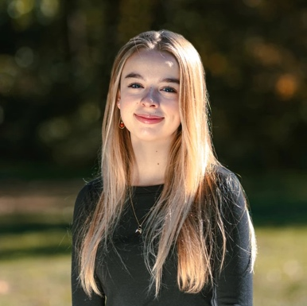  - I hate raisins  - I have a really cute puppy  - I’m going skydiving this summer | Martha Laramore-Josey    - I’ve never eaten a cheese stick  - If I were a demigod, my godly parent would be Iris (goddess of rainbows)  - My favorite key signature is A# minor

amazing altos

Ella Wickham  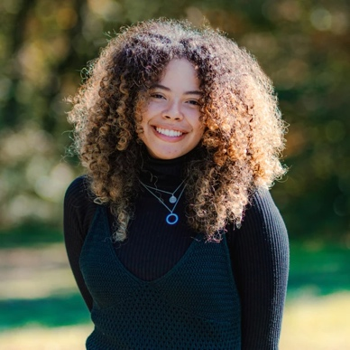  - I played ice hockey for 10 years  - You can spot me in the new Gossip Girl  - My favorite genre of music is heavy metal, due to its therapeutic and anger-alleviating properties | Lisa Choe    - I was a lifeguard in high school  - I have a pet chinchilla  - My favorite color is white

terrific tenors

Akshay Nambudiripad    - I used to be the best in my home state at Simpsons trivia  - I have a pet cat named Doug  - I’ve been vegetarian my whole life | Schimon Dieseler    - I spent a year of my life in Seville, Spain to study  - I play saxophone  - I have a Russian girlfriend

breathtaking basses

Armando Montenegro  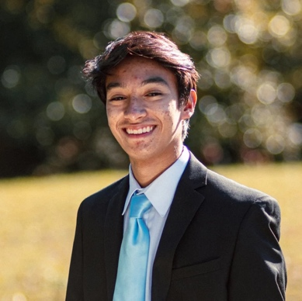  - I generally dislike hip-hop  - I have jumped into a Low plaza fountain  - My favorite singer is Erykah Badu | Bruno Becher  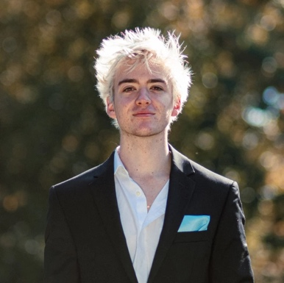  - I’ve been bitten by a wild monkey  - I’ve met Obama  - I used to want to be a professional yo-yo-er | Michael DiJoseph  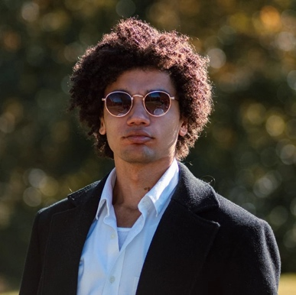  - I got hypothermia in mid-April once  - I was in a furry musical in high school  - I’ve never eaten raw fish and I don’t intend to

Akshay
- I used to be the best in my home state at Simpsons trivia
- I have a pet cat named Doug
- I’ve been vegetarian my whole life

Armando
- I generally dislike hip-hop.
- I have jumped into a low plaza fountain.
- My favorite singer is Erykah Badu.
Bruno
- I’ve been bitten by a wild monkey
- I’ve met Obama before
- I used to want to be a professional yo-yo-er
Celeste
- My chorus and I sang with Julie Andrews on TV
- In kindergarten, people would call me Lester (another popular one was Red)
- I once met Dora the Explora -- Boots, too. Unfortunately, Swiper couldn't make it.
Ella
- I played ice hockey for 10 years
- you can spot me in the new gossip girl
- my favorite genre of music is heavy metal due to its therapeutic and anger alleviating properties
Lisa
- i was a life guard in high school
- i have pet chinchilla
- my favorite color is white
Lizzy
- I hate raisins
- I have a really cute puppy
- I’m going skydiving this summer
Martha
- I’ve never eaten a cheese stick
- If I were a demigod, my godly parent would be Iris (goddess of rainbows)
- My favorite key signature is A# minor
Michael
- I got hypothermia in mid April once
- I was in a furry musical in high school
- I’ve never eaten raw fish and I don’t intend to
Schimon
- I spent a year of my life in Seville, Spain to study.
- I play saxophone.
- I have a Russian girlfriend.

